THE CITY OF BANDERA invites you to join us on February 18th at 5:15 pm for a Town Hall Meeting to discuss License Plate Reader (LPR) Technology

What Is LPR Technology?

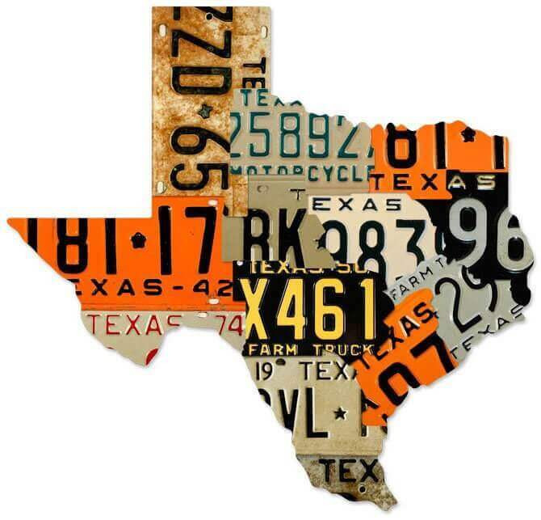
License Plate Reader (LPR) technology uses cameras placed in public areas to capture images of vehicle license plates. The system records:
- License plate number
-Vehicle make, model, and color
- Date, time, and general location
LPR technology does NOT capture faces, track people, use facial recognition, or monitor private property. The technology is used by the Bandera Marshal’s Office strictly for lawful public safety purposes.

Why Does Bandera Need LPR Technology?
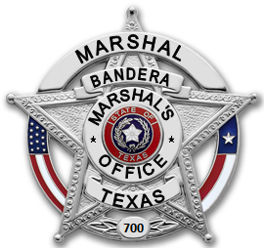
LPRs are a proactive tool to help keep Bandera safe. Community benefits include:
• Faster investigations
• Improved stolen vehicle recovery
• Efficient use of limited law enforcement resources
• Crime deterrence in public areas

Privacy & Accountability

The City of Bandera is committed to transparency and responsible use of LPR technology:
• Cameras are located only in public spaces
• Data is securely stored and retained for a limited time
• Access is limited to authorized personnel
• Use is governed by established policies and procedures

Working Together for a Safer Bandera
LPR technology is one of several tools used to protect residents, visitors, and local businesses while respecting individual privacy and civil liberties.

